**AIE500-901-FL**

Fanless Edge AI System with NVIDIA® Jetson™ TX2 Series, HDMI, 2 GbE LAN, 2 USB, 2 COM or 2 CAN, and 12 or 24 VDC

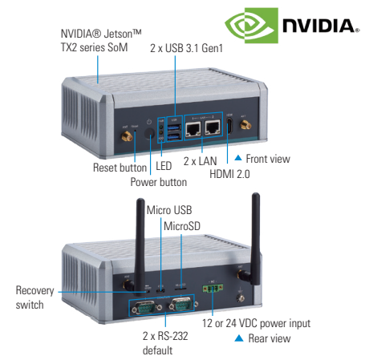

**Introduction**

The AIE500-901-FL is an advanced Artificial Intelligence embedded system for edge AI computing and deep learning applications. The high-performance embedded system employs an NVIDIA Jetson™ TX2 module which has a powerful 64-bit ARM® A57 processor; NVIDIA® Pascal™ GPU with 256 CUDA cores; and 8GB of 128-bit LPDDR4 memory. To withstand the rigors of day-to-day operation, the AIE500-901-FL has an extended operating temperature range of -30°C to +60°C and vibration of up to 3 Grms with its strong construction.

This fanless Artificial Intelligence edge system is dedicated to achieving operational excellence, efficiency, reliability in smart manufacturing and intelligent edge applications. The edge computing device provides solutions as Edge AI embedded system, specifically designed for video analysis, object classification, computer vision, quality control and more. Under the ultra-compact enclosure design, the AIE500-901-FL comes with 32GB eMMC onboard and is equipped with one M.2 Key M 2280 SSD slot with PCIe and SATA signal and one Micro SD slot for massive data processing and AI applications. Besides, this reliable embedded system has one full-size PCI Express Mini Card slot and one SIM slot for 3G/4G, GPS, Wi-Fi and Bluetooth connections.



**Features:**

* NVIDIA® Jetson™ TX2 with Pascal™, 256 CUDA cores GPU
* High performance AI computing for GPU-accelerated processing
* Ideal for intelligent edge applications, machine learning, and computer vision
* Supports M.2 PCIe, SATA SSD, and MicroSD slots
* Supports 2 USB 3.1 Gen 1 and 2 COM or 2 CAN
* Wide operating temperature from -30°C to +60°C
* Supports JetPack

**High performance** **for AI computing for GPU-accelerated processing**

* NVIDIA® Jetson™ TX2i / TX2 4GB, TX2 module
* Dual Denver 2/2 MB L2 + Quad ARM A57/2 MB L2
* NVIDIA® Jetson Pascal™ GPU with 256 CUDA cores
* 8GB of 128-bit LPDDR4 memory
* 32GB Emmc (via Jetson TX2 8GB) onboard256 CUDA cores GPU

**Ready for Massive data processing**

* One M.2 key M 2280 with PCIe and SATA SSD Slot
* One micro SD slot

**Great Expandability for 3G/4G, GPS, Wi-Fi and Bluetooth connections**

* NVIDIA® Jetson TX2 8GB comes with built-in connectivity to 802.11ac Wi-Fi and Bluetooth-enabled devices
* One full size PCI Express Mini Card slot
* One SIM slot

**Specifications**

|  |  |
| --- | --- |
| **CPU Board** | * NVIDIA® Jetson™ TX2 |
| **CPU** | * HMP Dual Denver 2/2 MB L2 + Quad ARM® A57/2 MB L2 |
| **GPU** | * NVIDIA® Pascal™, 256 CUDA cores |
| **Chipset** | * SoC integrated |
| **AI Accelerator** | * N/A |
| **System Memory** | * 8GB 128-bit LPDDR4@1866 MHz onboard |
| **COM** | * 2 x RS-232 default (or 2 x CAN by jumper settings) |
| **USB** | * 2 x USB 3.1 Gen1 * 1 x Micro USB |
| **Ethernet** | * 2 x 10/100/1000 Mbps Ethernet (NVIDIA® + Intel® i210-IT) |
| **Display** | * 1 x HDMI 2.0 with 4K2K supported |
| **Digital I/O** | * N/A |
| **Audio** | * N/A |
| **Storage** | * Onboard 32GB eMMC (via Jetson™ TX2 8GB) * 1 x M.2 Key M 2280 with PCIe x1 and SATA SSD slot * 1 x Micro SD slot |
| **Expansion** | * 1 x Full-size PCI Express Mini Card slot (USB + PCI Express signal) * 1 x SIM slot |
| **Others** | * 1 x Recovery switch * 1 x Reset button * 1 x Power button * 1 x 12 or 24 VDC power input connector * 4 x SMA-type antenna connector * 802.11ac WLAN, Bluetooth onboard (TX2 8GB only) |
| **Power Supply** | * 12 or 24 VDC |
| **Operating Temperature** | * -30°C to +60°C (-22°F to +140°F) |
| **Weight (net/gross)** | * 1.2kg (2.64lb)/1.7 kg (3.75 lb) |
| **Certifications** | * CE, FCC Class A |
| **EOS Support** | * Linux Ubuntu 18.04 |
| **Mounting** | * Wall mount kit * VESA arm kit * DIN-rail kit |

**Optional**

* 8817H500020E Wall mount kit
* 827H5000040E VESA arm kit
* 827H5000050E DIN-rail kit
* 50956A24040E 12V, 36W adapter
* M.2 NVMe SSD 128GB or above
* M.2 SATA SSD 128GB or above
* LTE module
* power cord

**Power Protection**

* DC Version
* OVP (over voltage protection)
* OCP (over current protection